Module 6 Conditionals
Part 1 Travelling by plane

Read Danny’s blog. What happened to him on the plane?
Look at the highlighted grammar examples. Do they describe future, present or past situations; real or unreal situations?

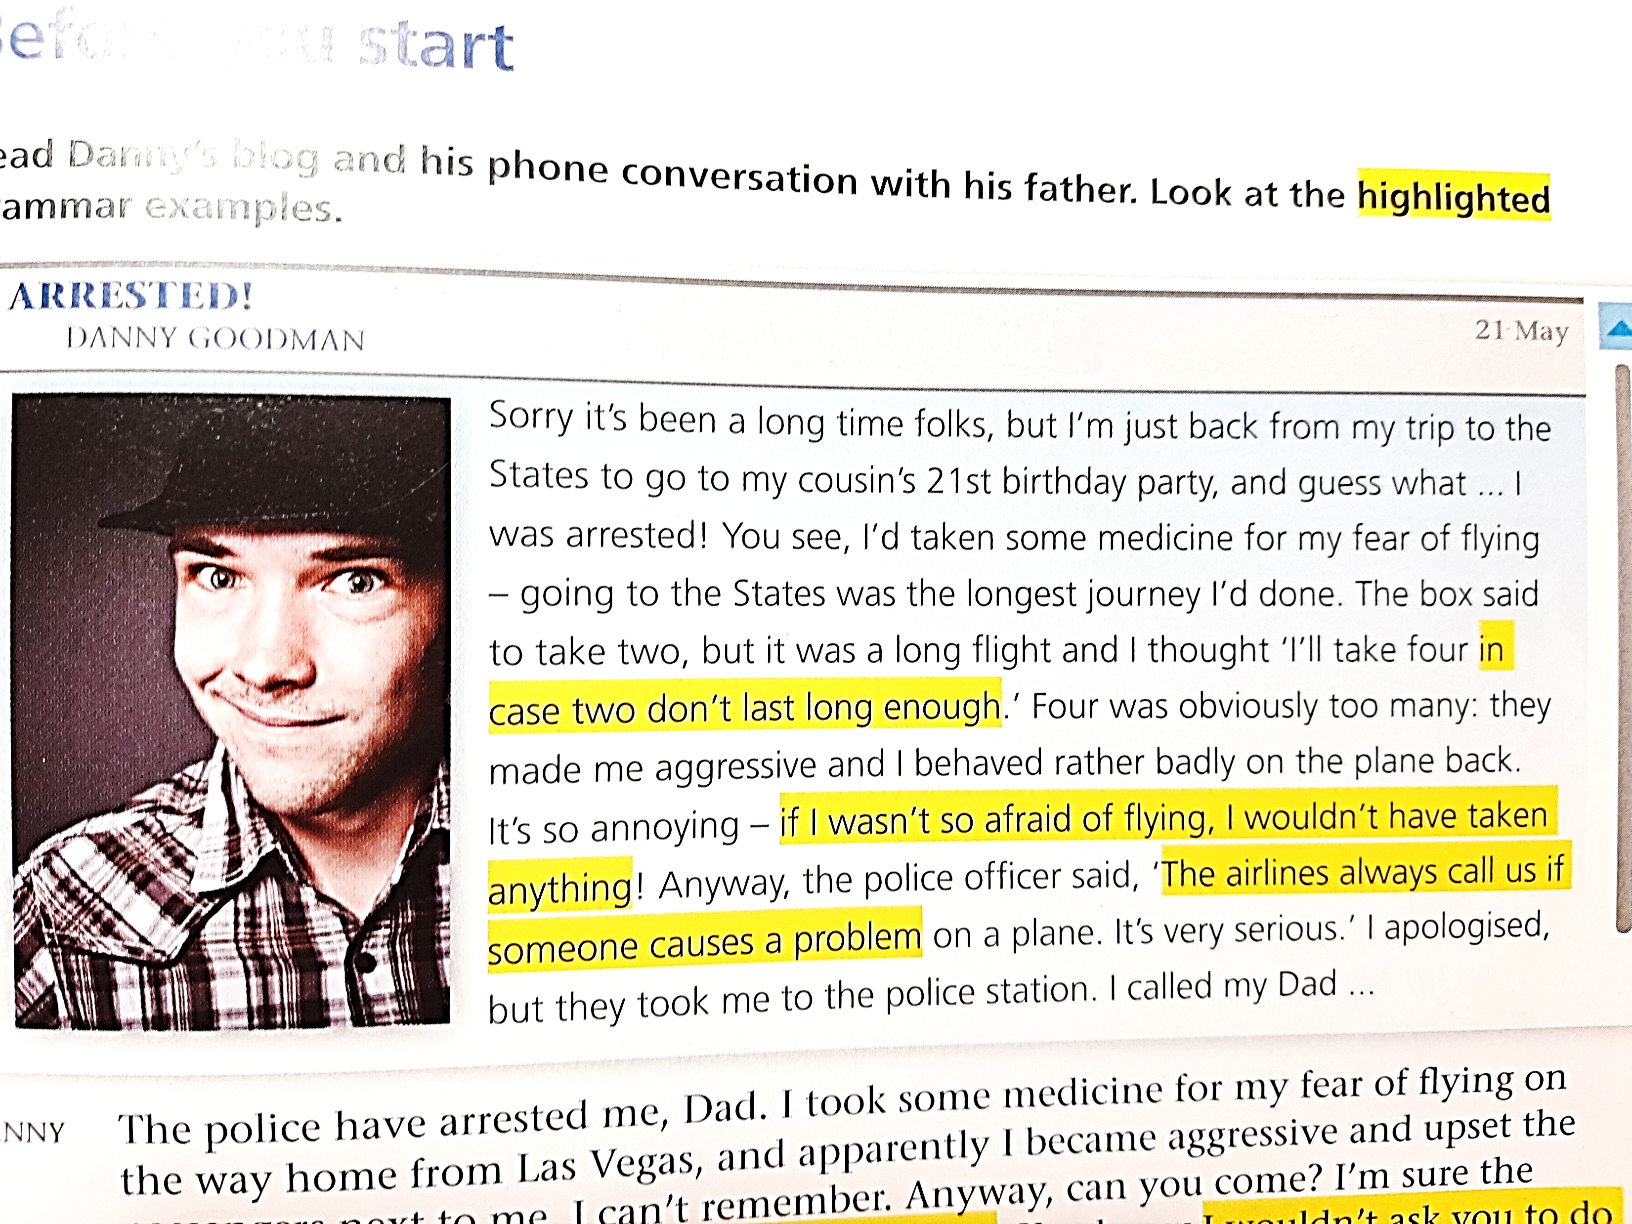

Read Danny’s phone conversation with his father and look at the highlighted grammar examples.
Do they describe future, present or past situations? Real or unreal situations?

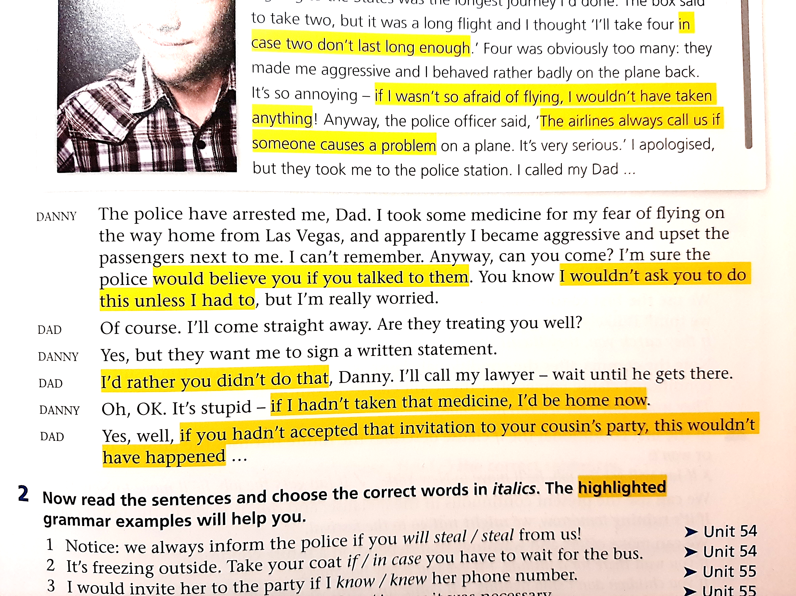

(from the textbook “Grammar Lab”)

